### Current Activities

The last two months have been relatively quiet. We continue to enhance some display areas, as well as yet more cataloguing of artefacts. In preparation for the introduction of GDPR, the web site has been updated to remove people’s names from the Photographs section. The data is still on the database, but is withheld when displayed.

Hursley celebrates 60 years of IBM presence on the site during 2018. Celebrations will take place in September, and the museum has been asked to provide some additional displays on the ground floor of the House. A week before this, Hursley opens its doors for the Heritage open weekend, so the museum will be preparing exhibits for both occasions.

The museum has been asked to support the Royal Hampshire County Hospital in its celebrations of 70 years NHS in June. The aim is to display office equipment alongside medical equipment to show a wider picture of the environment both in front-end medicine and office support. The only artefact we have from the days of IBM's Medical Division is a line drawing of an IBM Heart-Lung machine used in the 1950s. We will however be lending typewriters, PCs and other office artefacts for the week.

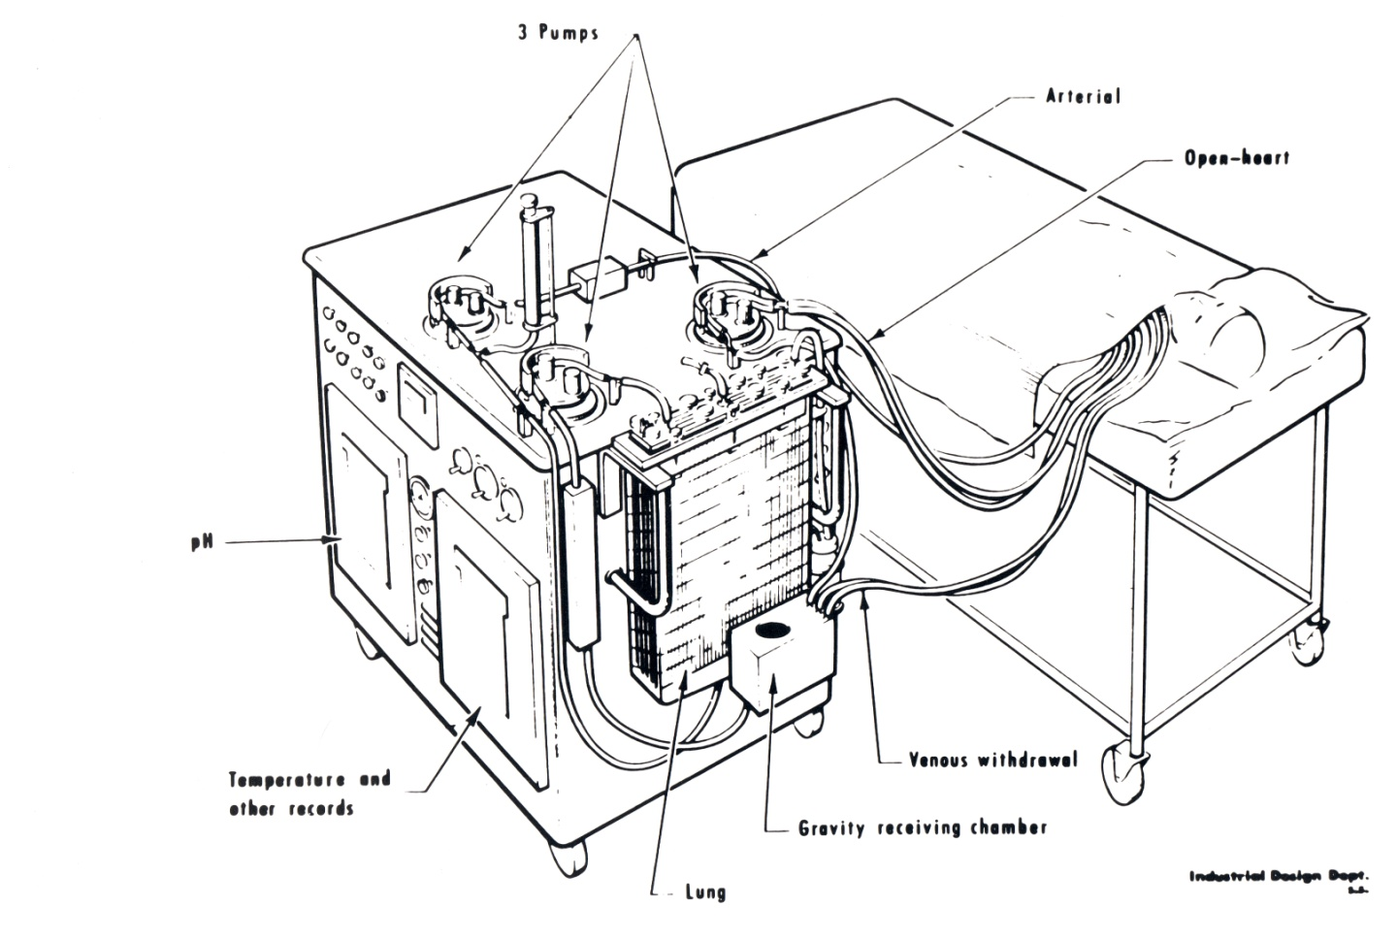

The IBM Heart-Lung Machine, or Oxygenator III

In 1947, in response to a request to Thomas Watson Snr. from a doctor at the Jefferson Medical College, IBM agreed to take part in the R&D required to produce a heart-lung machine. Three models were built, the one illustrated here was delivered in late 1954 and regularly used during the 1950s in the College operating theatre.